Microsoft 365 Copilot Guide
Overview
The purpose of this guide is to provide a resource with which students can leverage the Microsoft 365 Copilot Artificial Intelligence (AI) tool to complete the Lesson Plan and AI Assignment.

Instructions

Be sure to review all steps

Step 1: Open Copilot in your Teams app (Figure 1) or, if you have the appropriate license, you can use Copilot in your local Word app. The caveat is that you must be signed in with your Liberty University account for Copilot to access files on your local computer or in the cloud.

Figure 1
Copilot Chat in Teams

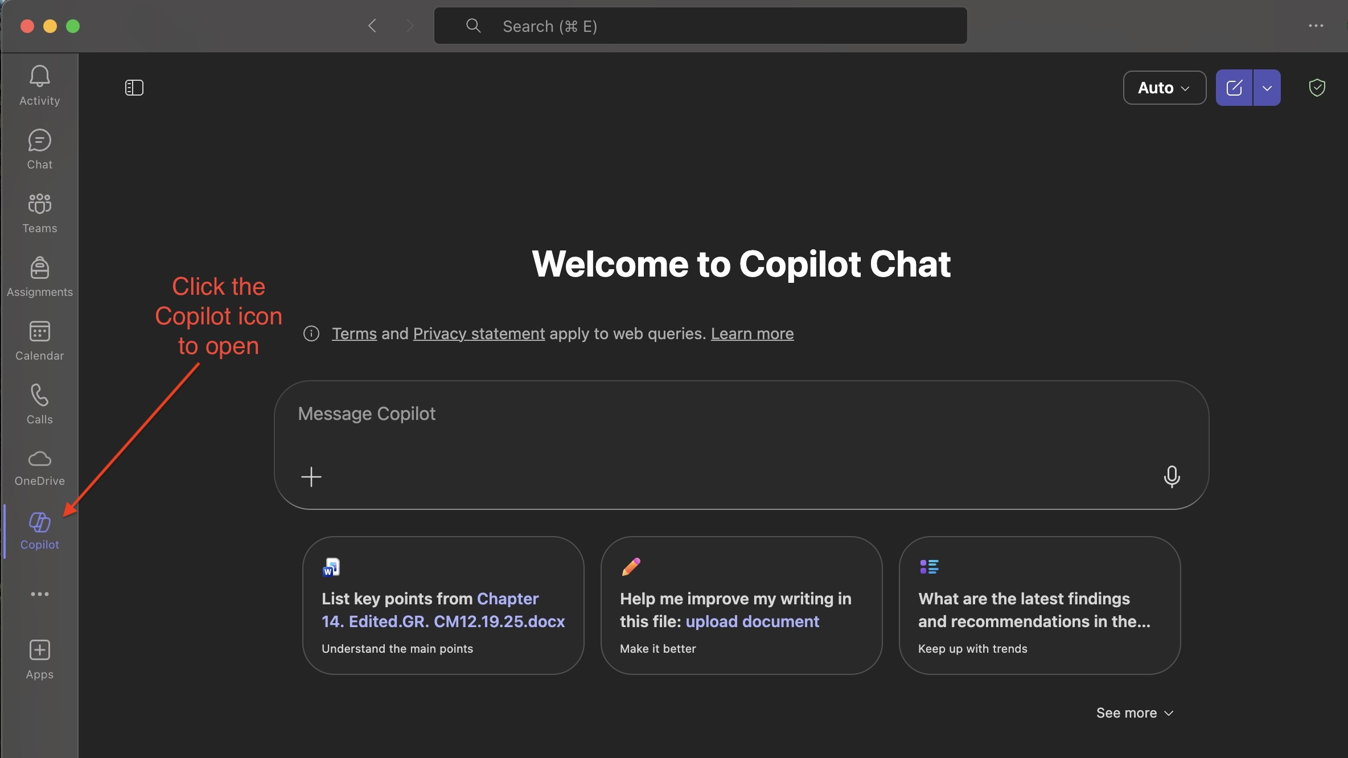

Step 2: Provide Copilot your instructions and upload the necessary reference files. For example, to complete the Lesson Plan and AI Assignment, the user might provide Copilot with the following directions: “Using the attached Sample Lesson Plan document and the attached 2024-CACREP Standards-with-citations document, adapt the Sample Lesson Plan to change from the CACREP specialization of CMHC to Rehabilitation and Addictions” (Figure 2). Then the user would upload the Sample Lesson Plan document and the 2024-CACREP Standards-with-citations document (Step 3).

Figure 2
Provide Copilot with Instruction
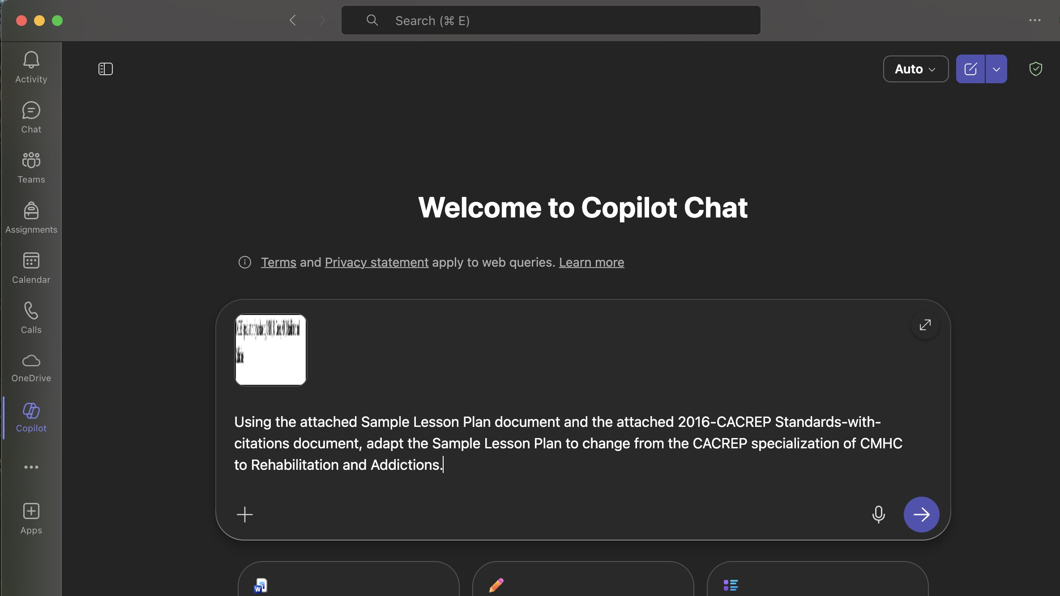

Step 3: In the dialogue box, there is a button in the lower left corner with a “+” symbol. To upload files for Copilot to use, click the “+” button (Figure 3).

Figure 3
Button to Upload Files to Copilot
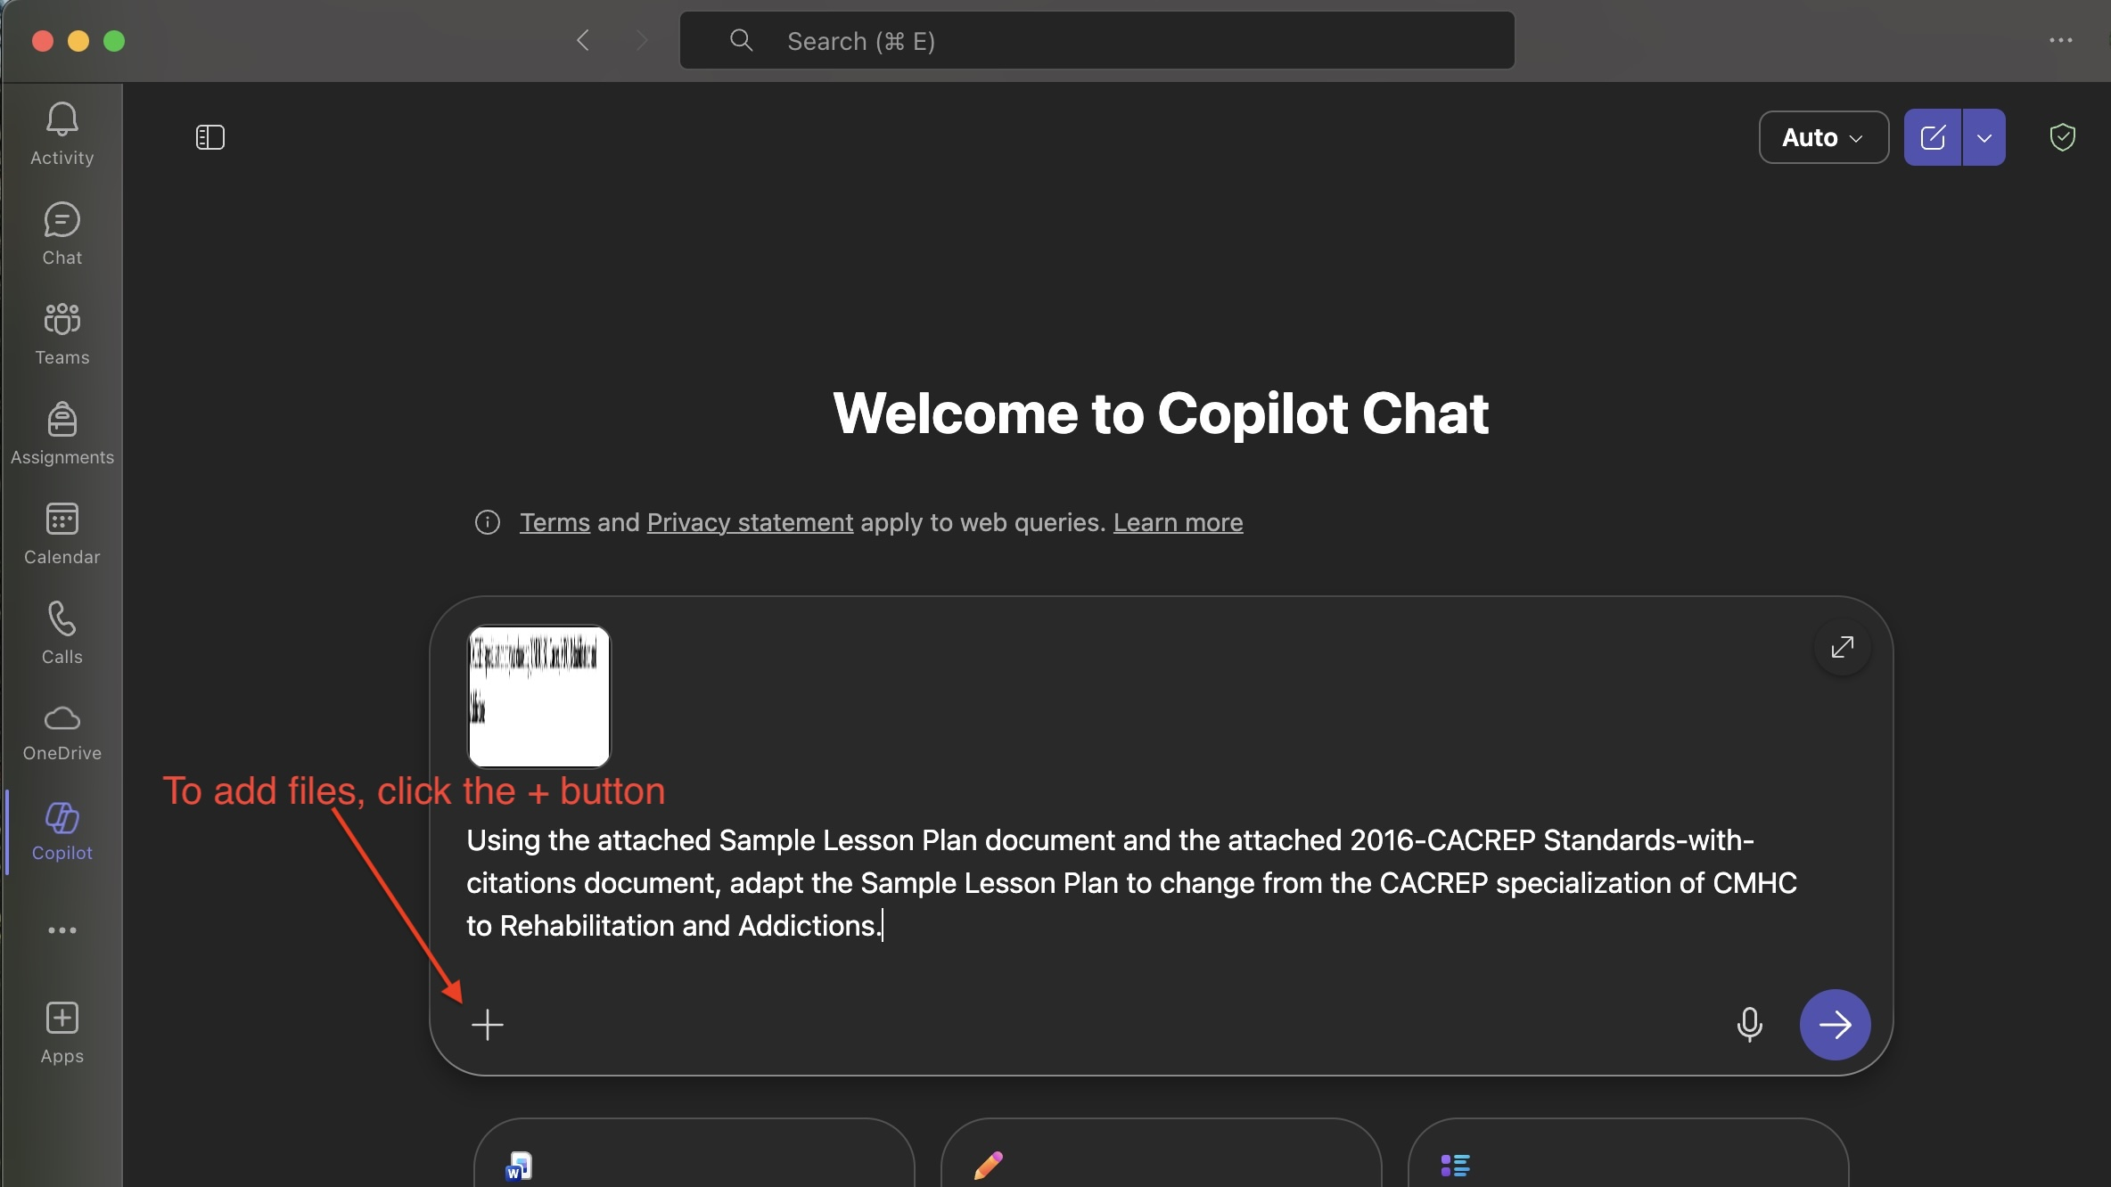

Step 4: Clicking the “+” button will open a dropdown menu. Select “Upload images and files” (Figure 4).

Figure 4
Selection for File Upload
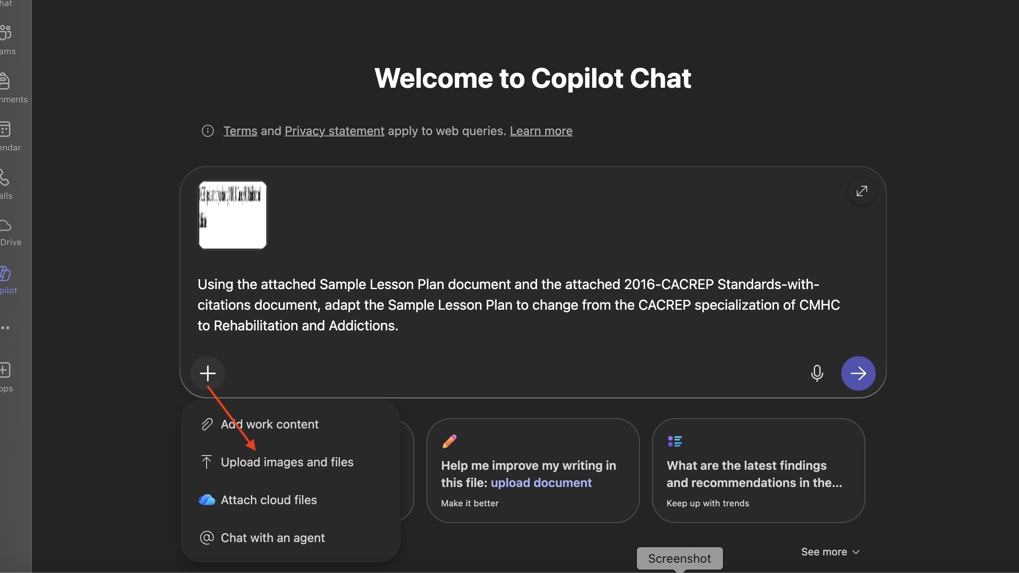

Step 4: After clicking on “Upload images and files,” a popup window will appear from which you can navigate to the correct location in your file system to select the applicable files (Figure 4).

Figure 4
Popup Window for File Selection
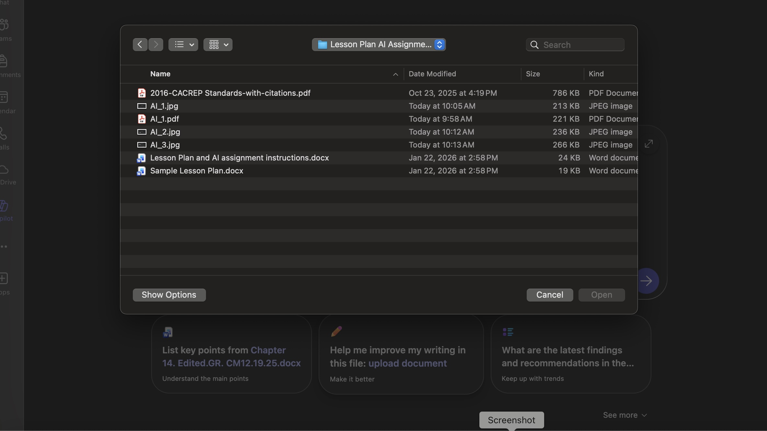

Step 5: Single click on the file(s) that you would like to select for upload. Once they are highlighted, click the “Open” button to upload the file(s) to Copilot (Figure 5).

Figure 5
Click Open Button to Upload Files
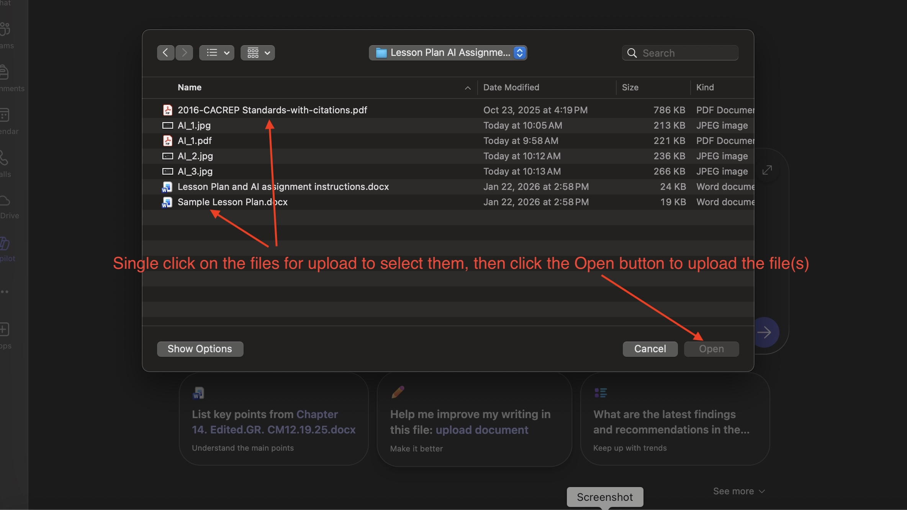

Step 6: Once the file(s) have been successfully uploaded, they will appear in the dialogue box with your typed instructions (Figure 6).

Figure 6
File Upload Verification
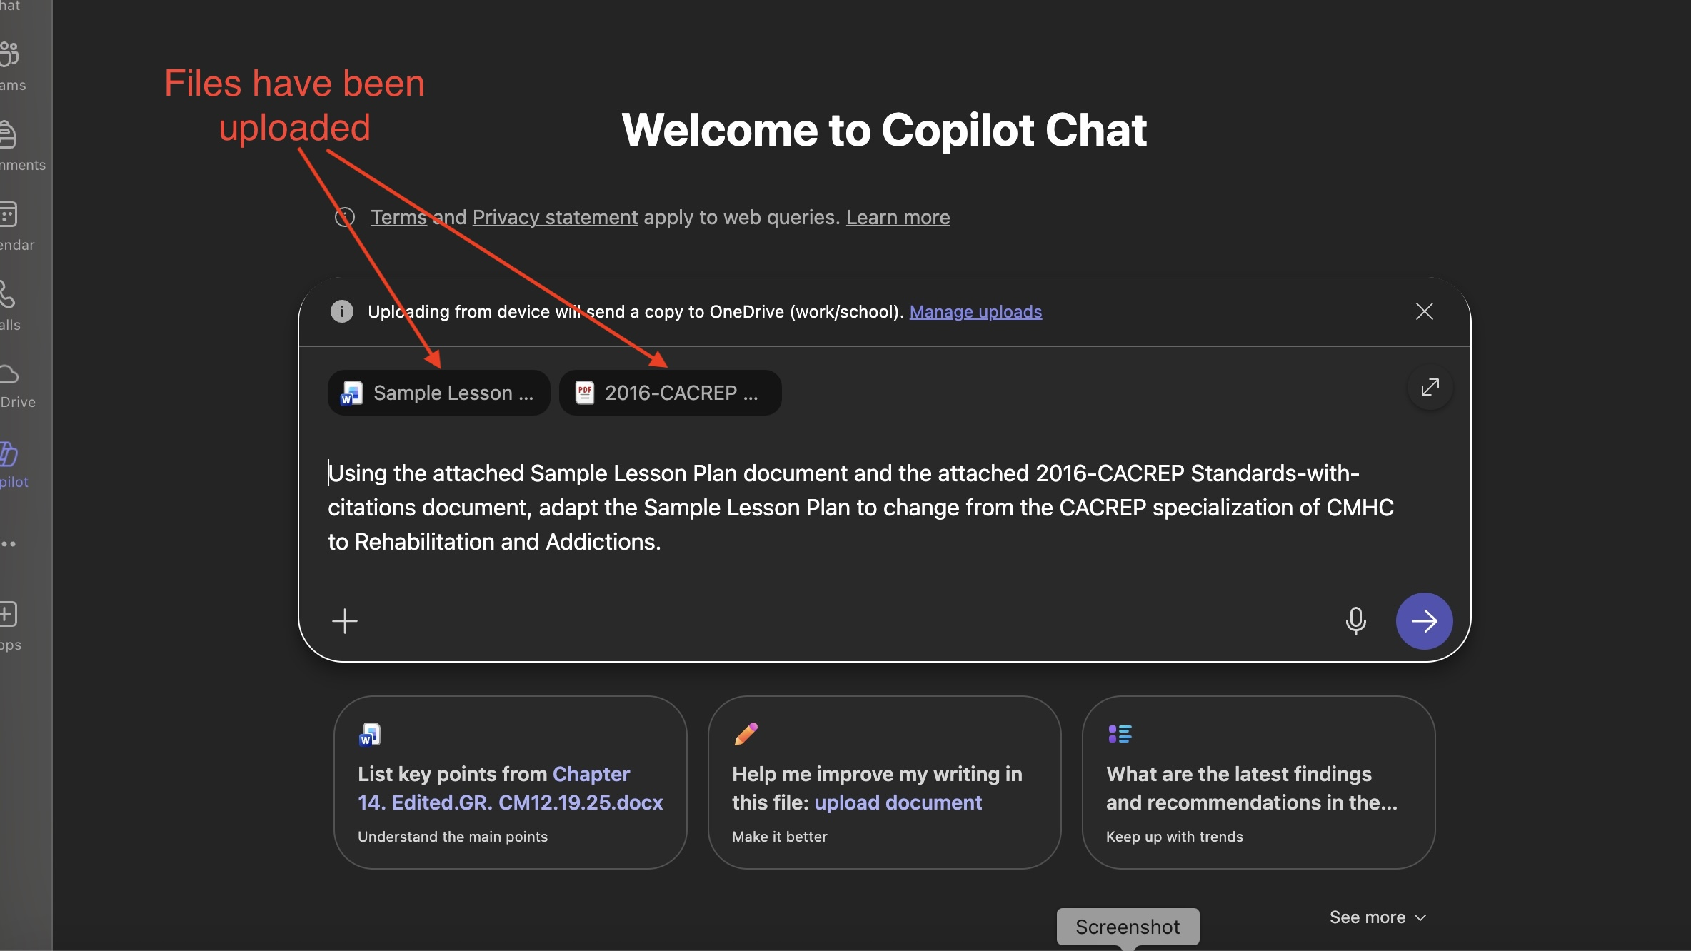

Step 7: Once the appropriate instructions have been typed and the file(s) uploaded, click the blue, right-facing arrow in the lower right corner of the dialogue box to start processing by Copilot (Figure 7). Once Copilot starts processing, the screen should look like what is depicted in Figure 8.

Figure 7
Click the Blue Button to Start Copilot

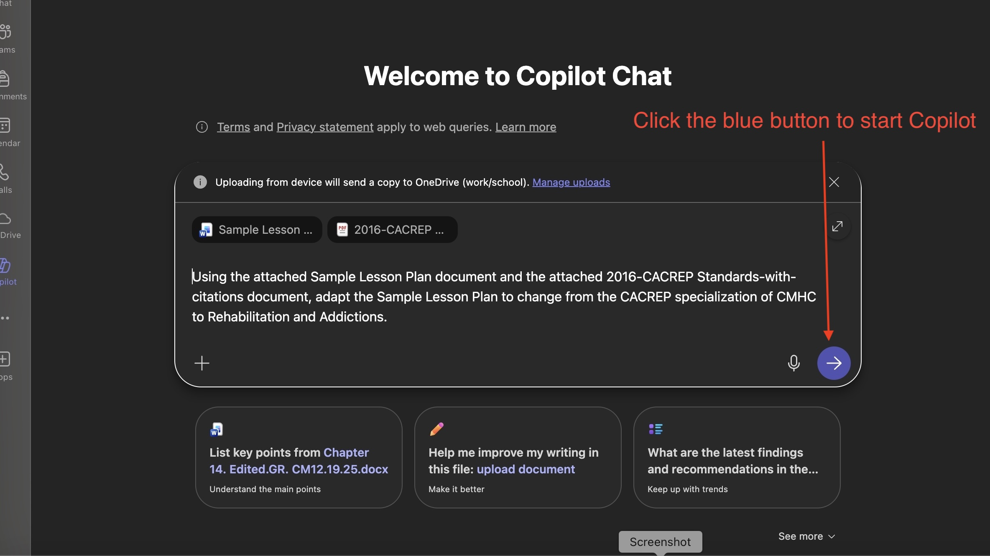

Figure 8
Copilot is Processing
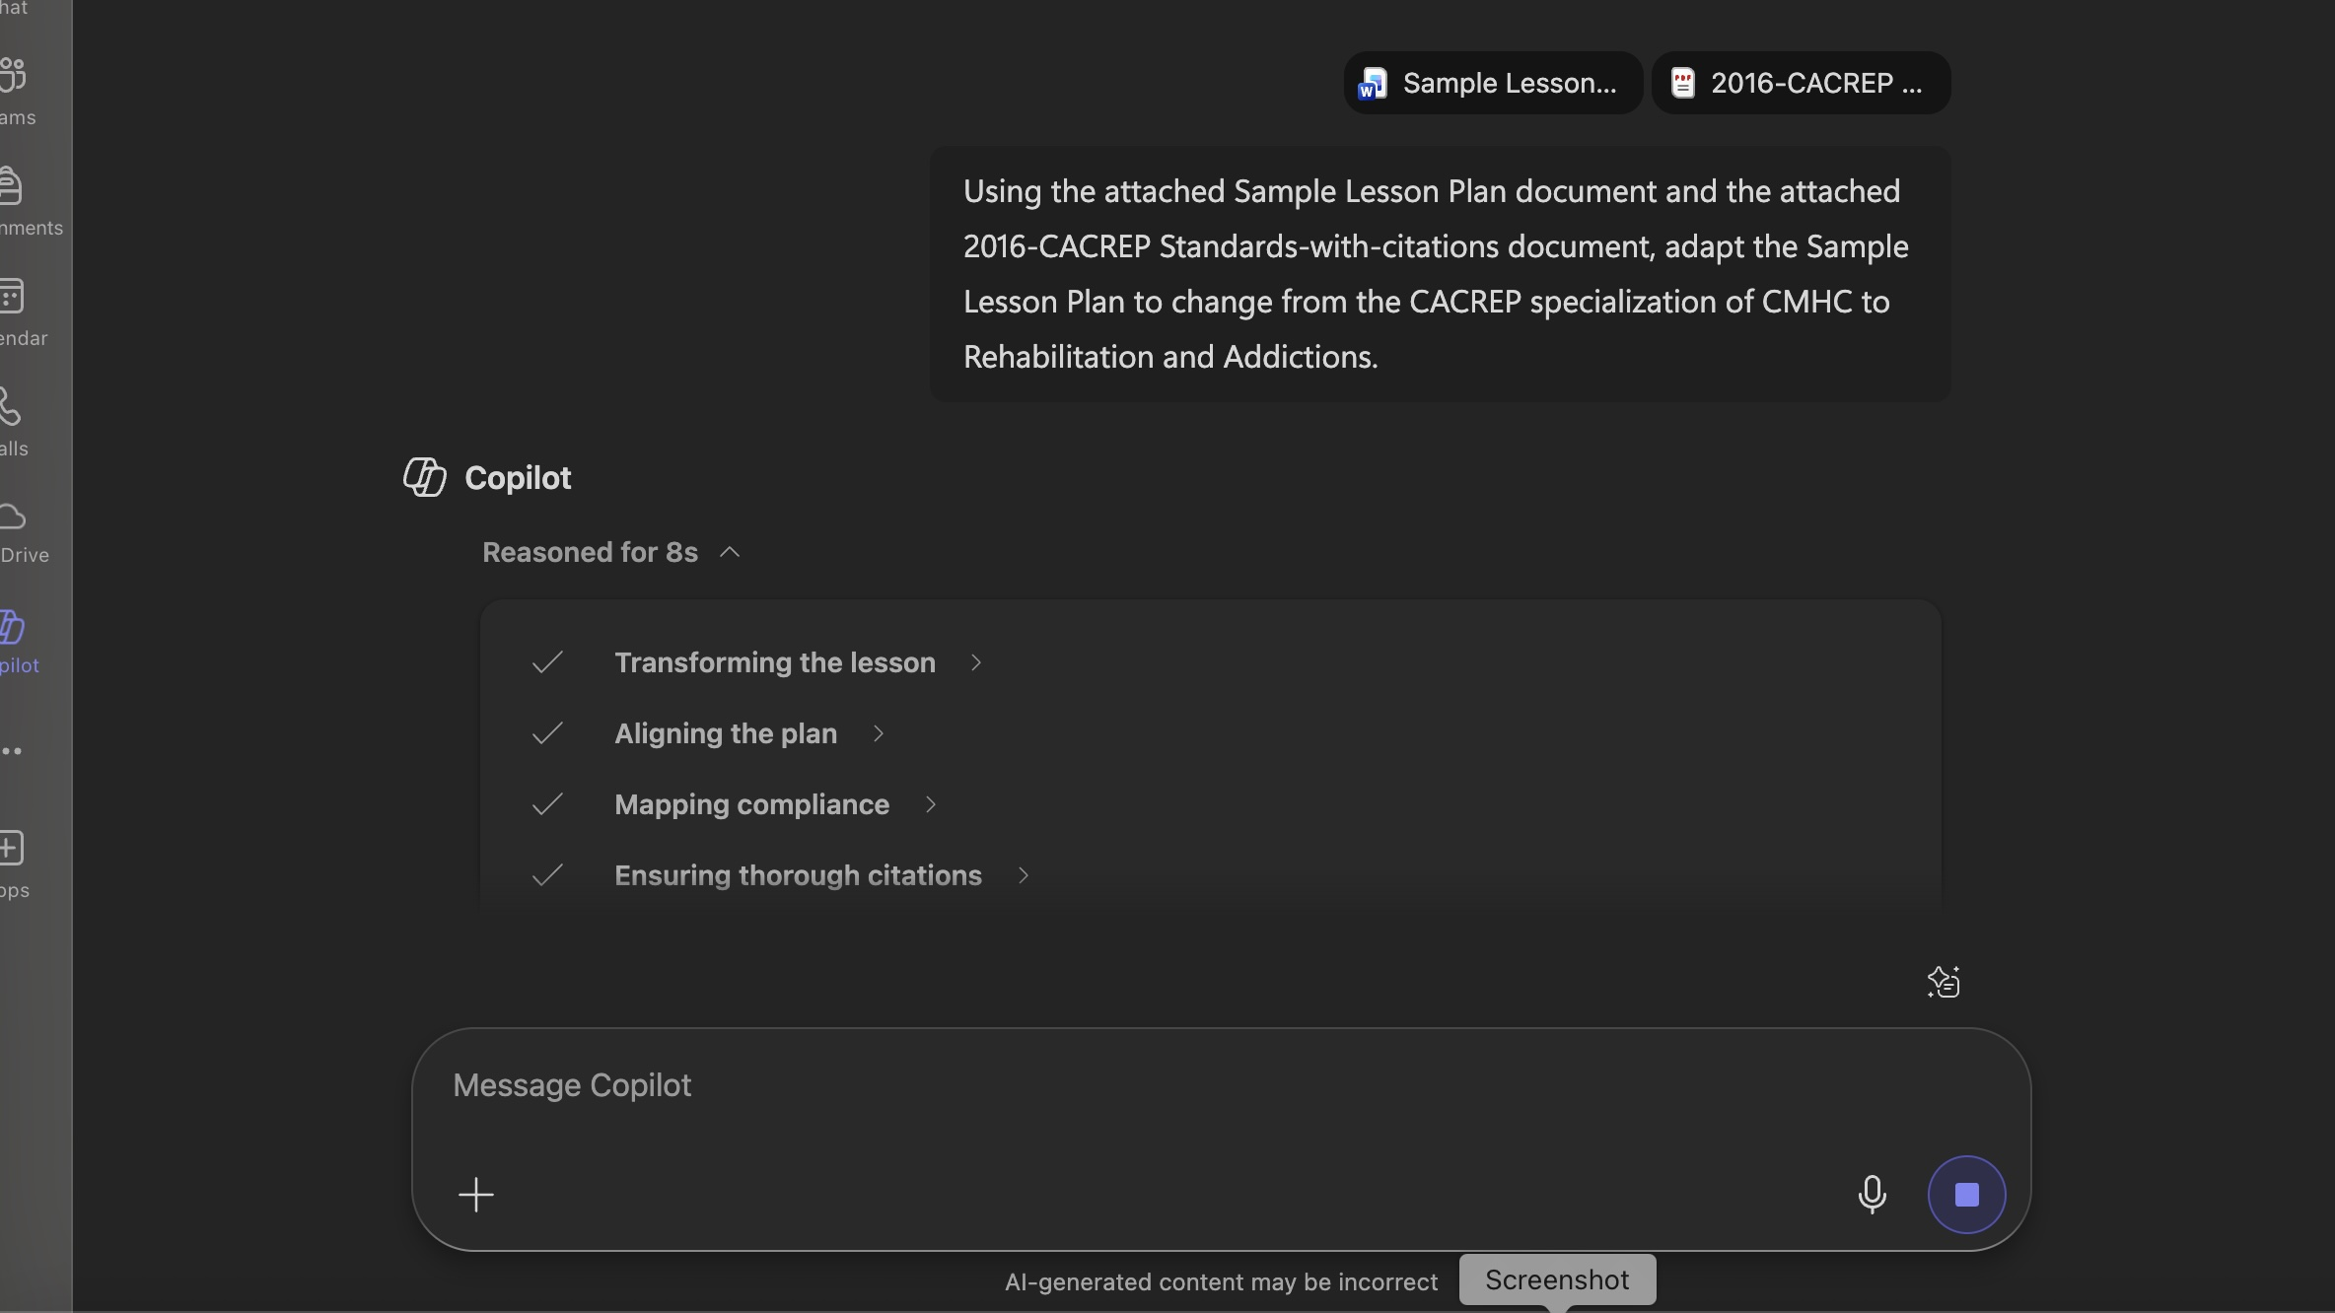

Step 8: Once Copilot has finished its processing of the instructions, the user can scroll down to review the output, as well as copy the output (Figure 9).

Figure 9
Copilot Finished Processing
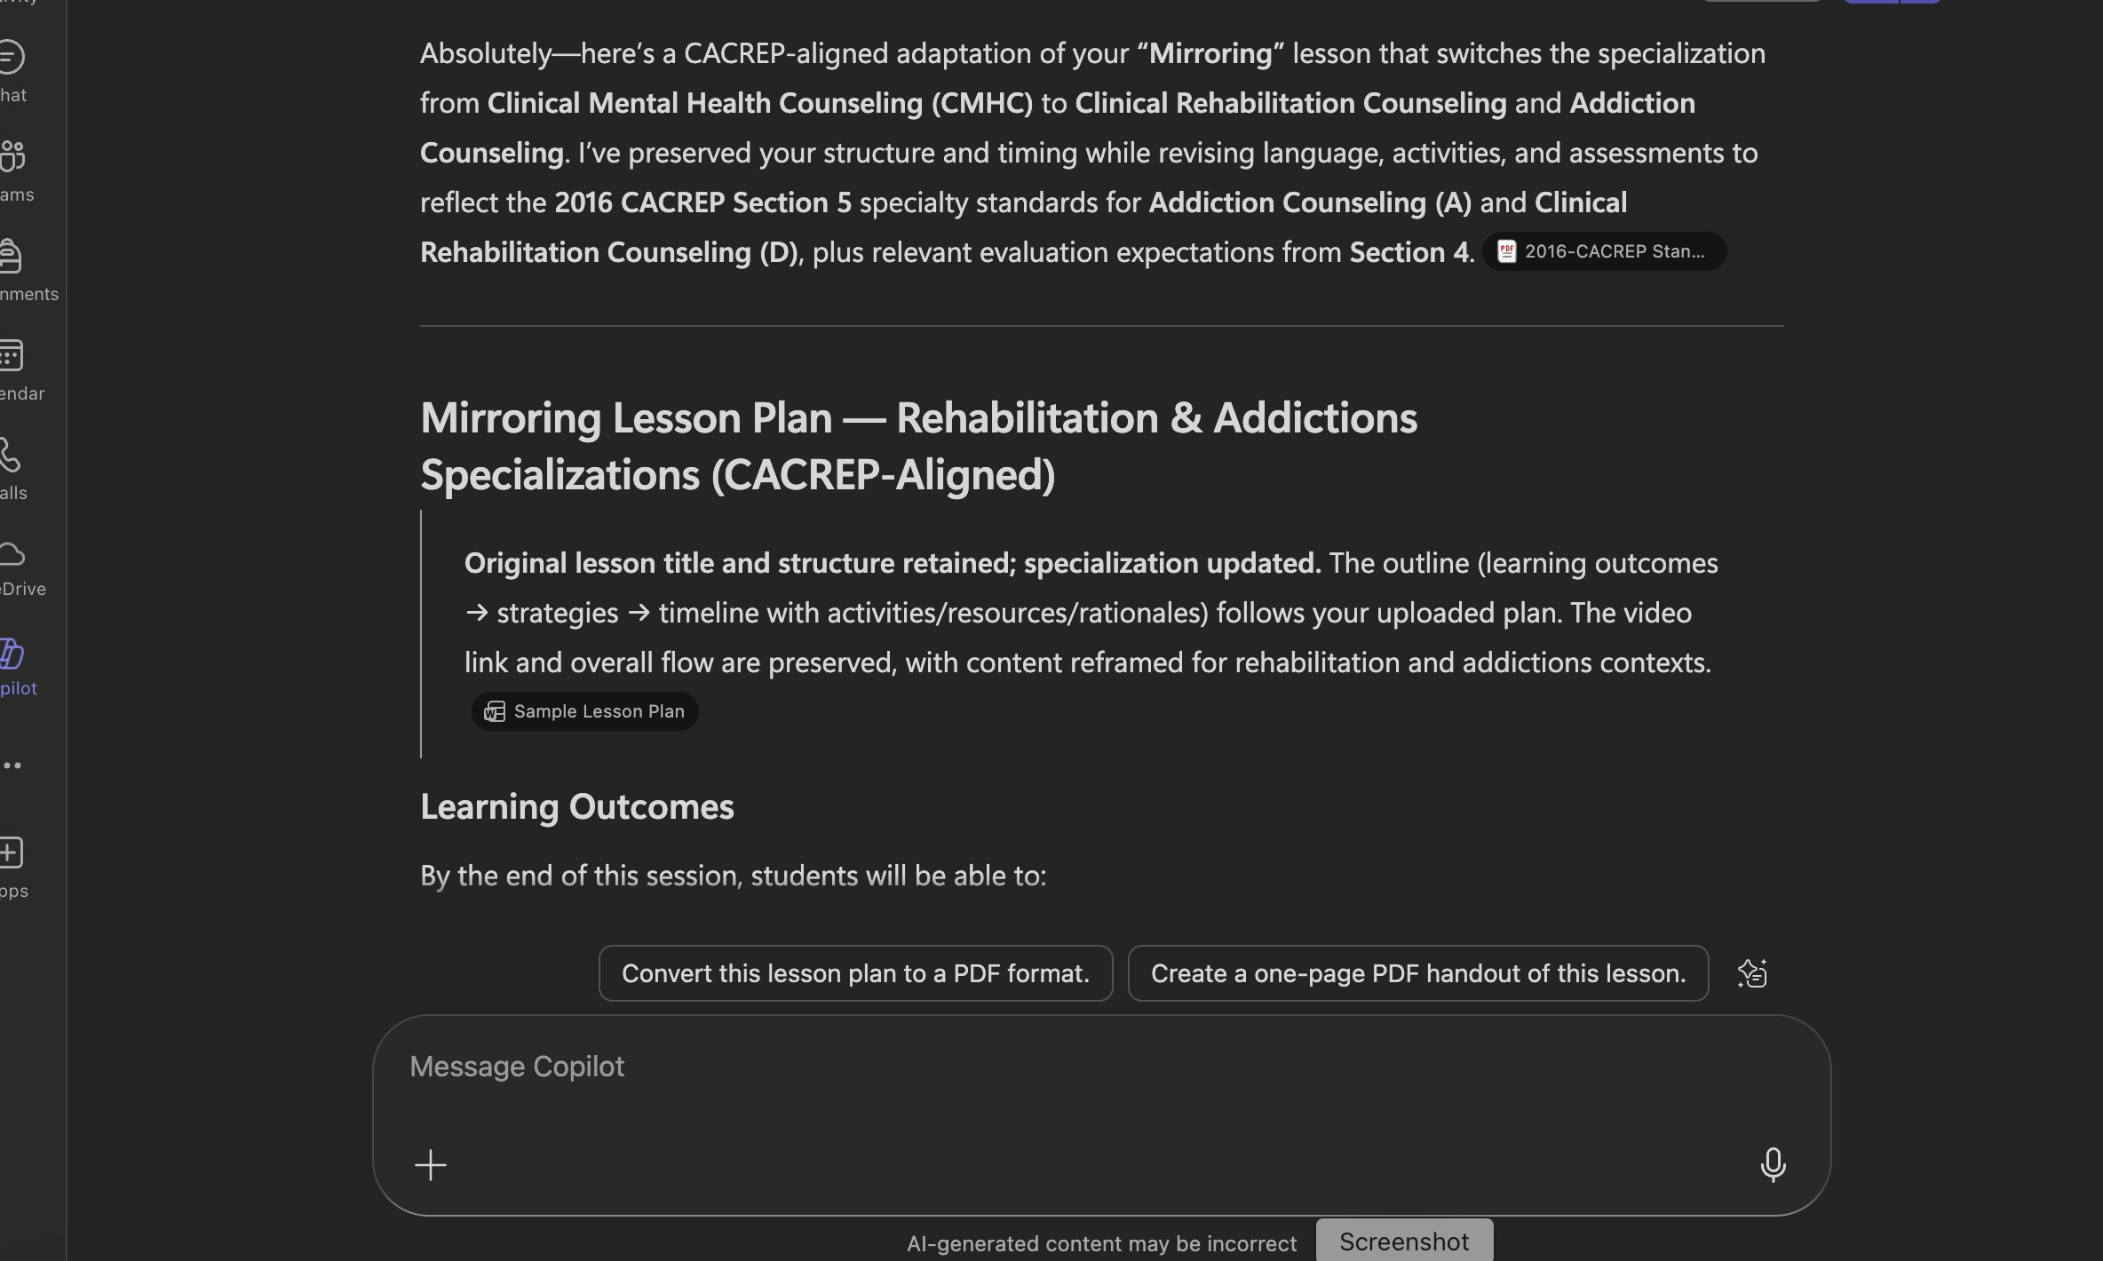

The output of the Copilot task can be seen below:
Absolutely—here’s a CACREP-aligned adaptation of your “Mirroring” lesson that switches the specialization from Clinical Mental Health Counseling (CMHC) to Clinical Rehabilitation Counseling and Addiction Counseling. I’ve preserved your structure and timing while revising language, activities, and assessments to reflect the 2024 CACREP Section 5 specialty standards for Addiction Counseling (A) and Clinical Rehabilitation Counseling (D), plus relevant evaluation expectations from Section 4. [2024-CACRE…-citations | PDF]

Guide developed for COUC 747, Liberty University by Glen Roberts, 2026

